Montrose Schoolhouse, circa 1812, is last of the township's six one-room schoolhouses. Situated on the corner of Cedar Drive and Montrose Road, it is the only one that retains its original architectural profile. We are not certain when the school was originally built but all sources agree that the structure was built before 1820, maybe 1790 or possibly 1805. The Montrose School was originally known as the Barrenton School located in "the Barrens" just to the west and moved to its present location. Its name was changed at that time. With the opening of the Atlantic School on Route 537 in 1922, the school ceased operation. It remained the property of the Emmans family until 1965 when it was donated to the now defunct Colts Neck Historical Society. It sat for over three decades opening only once for a historic Colts Neck house tour. In 2003 it was deeded to the Colts Neck Twp for $1 and restored by the Colts Neck Township Committee under the strict guidance of then Mayor Lillian Burry and the Historical Preservation Committee. The Montrose Schoolhouse retains its original pumpkin pine floors, a potbelly wood burning stove and a collection of period school desks. The Montrose Schoolhouse is opened on special occasions.

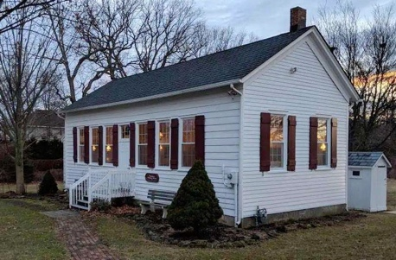

The Blansingburg Schoolhouse Museum is a one room school built in 1855. It was in use from 1856-1935. Moving it to this site in 1999 was quite a project. The tin walls, ceiling, wainscoting and black- board were still intact. It was restored and furnished with old desks (some original), books and memorabilia. It is used twice a week for teaching Wall's 2nd grade students. Girls in their pinafores and boys in suspenders are taken back to the 1800's to do math on chalkboards and read from McGuffy's readers.

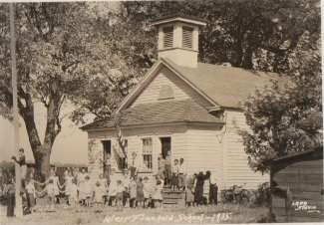

The West Freehold School, earlier known as the West Freehold Seminary and Collegiate Institute, was built in 1847 on a small piece of the Walker-Combs-Hartshorne Farm (later Oakley) when the area was known as the Freehold Corner District. The building which educated what was later numbered District 11, was occupied for instructional use until a 1936 township school consolidation. Owned by the Township of Freehold, the building is operated for historical interpretation by the Freehold

Township Historic Preservation Commission. While the commission has traced ownership to the late 17th century, this lot was deeded by Rulif R. Schanck, the source of a nickname "the Old Schanck School" to school trustees Samuel Conover, William W. Thompson and John H. Mount June 8, 1847 as recorded in Deed Book E5, page 336. Freehold Township takes special pride in its educational history as it holds the distinction of owning two former one room schools, the other District 9 named for the Georgia neighborhood.

Originally started in 1735 by a land grant from King George, this old one room schoolhouse is the oldest remaining schoolhouse in Freehold Township. Thus the name, "Georgia" was used to describe the area and the schoolhouse. The property was granted with a stipulation that it always be used for educational purposes. The original schoolhouse on this site was a log cabin which was replaced after a fire around 1820 by a wooden structure slightly smaller than what stands there today. In 1862, that building was replaced with the current structure. The wood to build the school was harvested from the trees on the original school lot. The school operated from 1735 until 1935 in the state's 9th school district. Reopened in 1950 as a school for special needs children, this is the oldest remaining school in the township.

Court Street School first opened in 1913, down the hill from its current location. It was a small, one-story wooden building on Avenue A and served Black students in grades one to eight. The Freehold Borough Board of Education formalized the school in 1915 as it continued educating children of Black migrants. The student population soon outgrew the original building. In 1919, the department of education built the current structure, just up the hill from the old building. Kindergarten was also added to the school. The Great Migration, the relocation of Blacks from the rural South to take advantage of burgeoning industrial jobs in the North, only boosted enrollment. Long-standing Black families in the area combined with new waves of African Americans, heightened the need for Court Street School. At the time, there were as many as 12 segregated elementary and middle schools for Black children in Monmouth County, but Court Street School was the only one in the western part of the county. The two-classroom school then grew to four classrooms, with two or three grades to a room. During World War II, the school was used as an air raid shelter and ration station. It integrated in the early 1950s, serving Black and white students through the third grade.

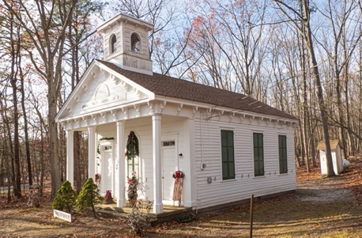

This school was built in 1855, and originally located across the street from the present-day Ardena Baptist Church, on Rt. 524. During its time of operation, it was the parents’ responsibility to hire and pay the teacher to work in the schoolhouse, so not everyone had the opportunity to obtain an education. Since Ardena only had a single room for instruction, all levels of learners were taught together. This encompassed a great range of ages, and the older students would often work independently or help the younger ones during the school day. When Howell’s Ardena Consolidated School opened in 1938, the individual district schools were no longer needed. The old building was sold to an adjacent neighbor, Roy Matthews in 1939, and it became storage for his carpentry tools. In 1946 he sold it to Victor Griffin, who moved it to Burlington Road, in Freehold Township, where it was used for his carpet-making business. In 1973, there was a push by the Howell Historical Society to preserve the building, and they were able to purchase the Old Schoolhouse for $3,000, and paid $1,400 to have it moved mid-summer of 1974, and located here, at the corner of Old Tavern and Preventorium Roads.